BlinkIT Sales Analysis

- Total Sales Amount by Fat Content;
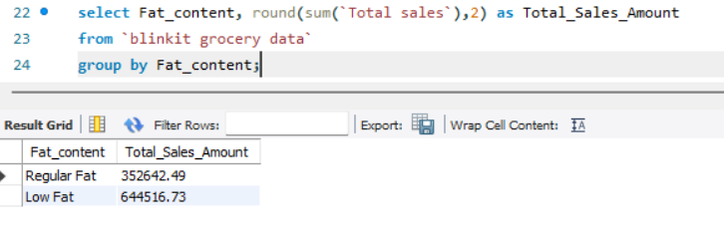

- Total Sales by Item Type

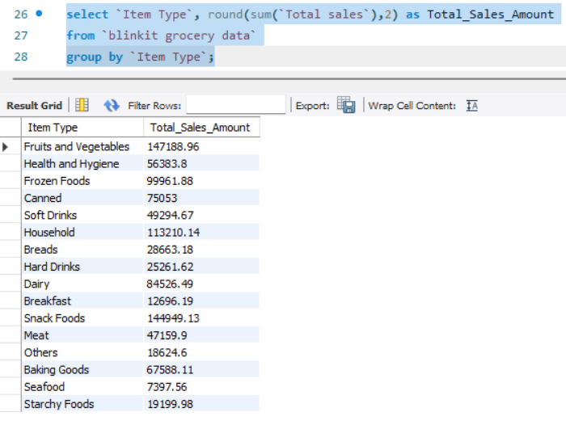

- Fat Content by Outlet Location Type for Total Sales

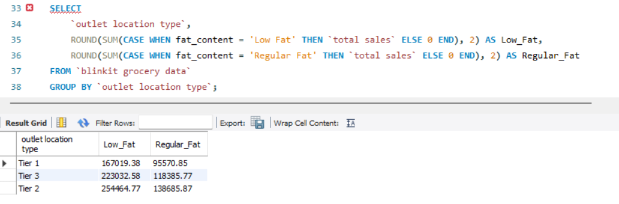

- Total sales by Outlet Establishment Year

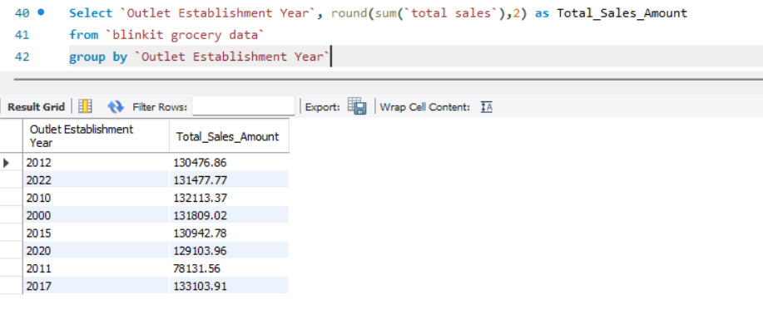

- Percentage of Sales by Outlet Size

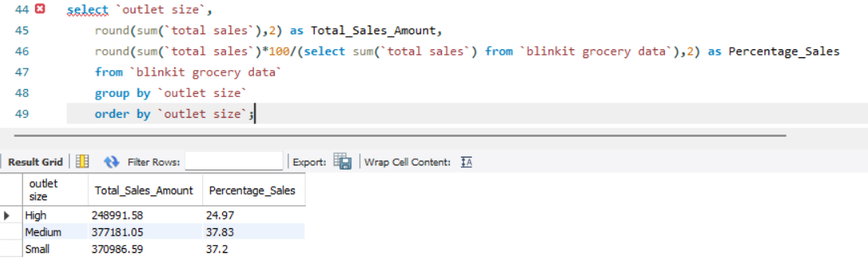

- Total sales by Outlet Location Type

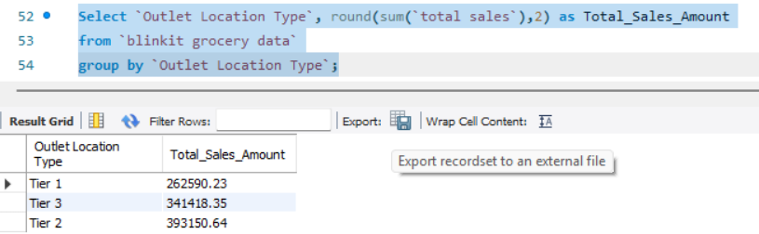

- All Metrics for different Outlet Location Type

